**Week 1 Notes: Introduction to Networks**

**Book Introduction**

* Networks are very important in this current Information Age
* The value of a high-speed data communications network is that it brings people together in a way never before possible.
* Reducing *information lag* to internet speeds means that people can now communicate and access information anywhere in the world.
* Data communications and networking is a truly global area of study.
* In networking, there are three fundamental questions:
  + How does the Internet work?

1. Software on your computer (or any other device) creates a **message** composed in different **software languages** (e.g. HTTP, TCP/IP, and Ethernet) that requests the page you clicked.
2. This message is then broken up into a series of smaller parts that we call **packets**.
3. Each packet is transmitted to the nearest **router**, a special-purpose computer whose primary job is to find the best route for these packets to their final destination.
4. The packets move from router to router over the Internet until they reach the **Web server** (that contains that webpage you requested), which puts the packets back together to the same message your computer created.
5. The Web server reads your request and then sends the page back to you in the same way—composing a message and sending it as packets.
   * How do I design a network?
     + We often think of networks in four layers.
6. Local Area Network (LAN): enables normal users to access the network; can be wired or wireless
7. Backbone Network: connects the different LANs within a building
8. Core Network: connects different buildings on a company’s campus
9. Wide Area Network (WAN): connections we have to other campuses within the organization and to the Internet
   * How do I manage my network to make sure it is secure, performs well, and doesn’t cost too much?
     + Companies spend $1500 – $3500 per computer per year on network management and security
     + Network management is not just a technology management issue; it is also a people management issue!

**Introduction**

* **Telecommunications (broad)** = transmission of voice and video (images and graphics) as well as data and usually implies longer distances
* **Data communications (narrow)** = movement of computer information from one point to another by means of electrical or optical transmission systems.
  + Collect data from clients, e.g. PCs and other devices
  + Transmit client data to a central server (a more powerful PC, minicomputer, or mainframe)
  + or do the reverse process (transmit server data to the client)
  + or some combination of the two (forward and reverse processes)
* **Data communications networks** = data transmission systems
  + Facilitate more efficient use of computers
  + Improve day-to-day control of a business by providing faster info flow
  + Provide message transfer services for email, chat, and video communication

**Components of a Network**

* There are 3 basic hardware components of a data communications network: a server, a client, and a circuit over which messages flow. Both the server and client also need special purpose network software that allows them to communicate.
  + **client** (e.g. PC, mobile devices, smart devices, terminal) = the input/output hardware device at the user’s end of a communication circuit; typically provides users with access to the network and the data/software on a server
  + **server** (e.g. PC, mainframe) = stores data or software that can be accessed by the clients…
    - **file server** =stores data and software that can be used by computers on the network.
    - **print server** = connected to a printer; manages all printing requests from the clients on the network.
    - **web server** = stores documents and graphics that can be accessed from any web browser; can respond to computers in other networks.
  + **circuit** = the pathway through which messages travel; typically copper wire, but fiber-optics and WIFI are becoming popular; there are many devices on the circuit that perform special functions, such as:
    - **switch** = circuit component that connects devices on a computer network by using packet switching to receive and forward data to the destination device; sends data in packets and frames.
    - **router** = special network device responsible for finding the best possible route for data; often combined with modems
    - **mod-/de-modulator (modem)** = hardware device that converts digital data into analog signals that can be transmitted over wires + vice versa.

**Types of Networks**

* There are many different ways to characterize networks and thus many different types of networks.
* Moreover, the distinctions among these various types of networks are becoming blurry; any rigid classification of technology is bound to have exceptions.
* One of the most common ways is to look at the geographic scope of the network.
  + **Local area network** (**LAN**) = a group of computers located in the same general area; covers a clearly defined small area; e.g. one floor, a single building, or group of buildings; does not have to be an urban area.
  + **Metropolitan area network (MAN)** = network that connects computers within a metropolitan area, e.g. a single large city, multiple cities and towns, or any given large area with multiple buildings.
  + **Backbone network (BN)** = a larger, central network connecting several LANs, other BNs, MANs, and WANs; typically span hundreds of feet to several miles; provide very high-speed data transmissions (100 – 1000 Mbps).
  + **Wide area network** = connects BNs and MANs over thousands of miles and provide transmission rates from 64 Kbps – 10 Gbps; organizations generally lease circuits from IXCs rather than build their own WANs.
  + **Internet** = a global system of interconnected computer networks that uses the Internet protocol suite (TCP/IP) to communicate between networks and devices; a *network of networks* that consists of private, public, academic, business, and government networks of local to global scope, linked by a broad array of networking technologies; interconnected ISPs.
* Another common way is to look at who can access the network.
  + **Intranet** = a LAN that uses the same technologies as the Internet but is open to only those inside the organization; sometimes, a Web server makes some pages available to the public and makes others hidden in the extranet; other times, an intranet is provided by a separate Web server completely hidden from the internet.
  + **Extranet** = a network that also uses internet technologies but instead is provided to invited users outside the organization who access it over the Internet; can provides access to information services, inventories and other internal databases exclusively to customers, suppliers, or other registered users; typically, users require passwords to gain access, but other technologies are common as well
* **Network architecture** is yet another way to look at the different types of networks:
  + Peer-to-peer network = network that connects a set of similar computers for sharing data *without* the use of a server; the computers function as “equals”.
  + Client-server network = network in which one centralized, powerful computer (called the **server**) is a hub to which many less powerful personal computers or workstations (called **clients**) are connected. The clients run programs and access data that are stored on the server.
* **What’s the Internet? “nuts and bolts view”**
  + Millions of connected computing devices; a “network of networks”:
    - *hosts* (e.g. clients, servers) = *end systems* (i.e. at the ends of networks)
    - running *network apps*
    - *interconnected ISPs*
  + communications links:
    - fiber, copper, radio, satellite, wireless
    - transmission rate = *bandwidth*
  + Packet switching = the transfer of small pieces of data (known as “packets”) across various networks
    - *routers* and *switches*
  + *protocols* control sending, receiving of messages
    - e.g., TCP, IP, HTTP, Skype, 802.11
  + *Internet standards*
    - RFC: Request for comments
    - IETF: Internet Engineering Task Force

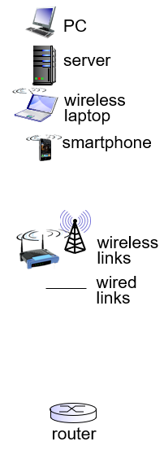 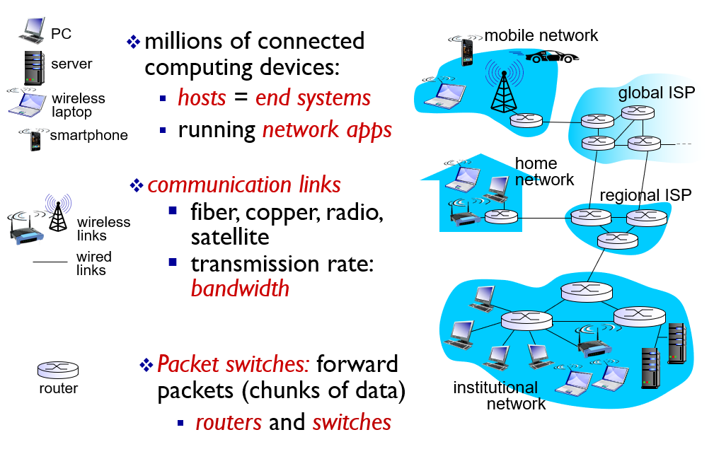

**What’s a protocol?**

* Protocol = a set of rules
  + human protocols
    - a set of rules governing communication
    - What’s the time? Say hello first, then ask the time
    - “I have a question” Build rapport, then ask the question
  + network protocols
    - a set of conventions/rules governing the treatment and especially the formatting of data in an electronic communications system
    - machines rather than humans
    - all communication activity in Internet governed by protocols
* ***Protocols*** define ***format***, ***order*** of ***messages sent and received*** among network entities, and ***actions taken*** on message transmission and receipt.

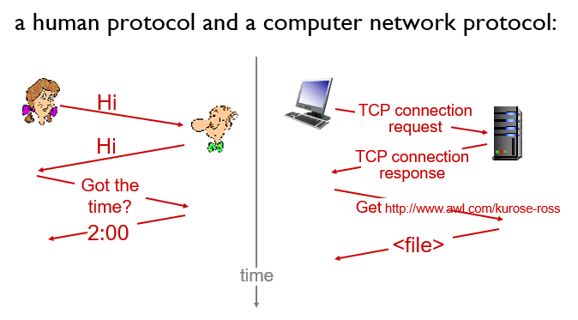

**A closer look at network structure:**

* *network edge:*
  + hosts: clients and servers
  + servers often in data centers
* *access networks, physical media:*
  + wired and wireless communication links
* *network core:*
  + interconnected routers
  + network of networks

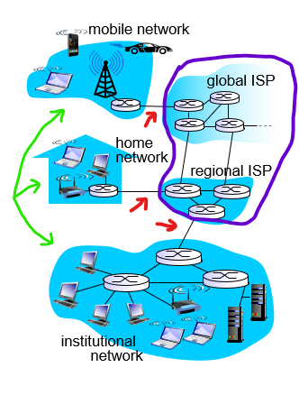

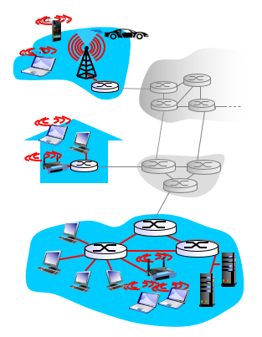**Access networks and physical media**

* How to connect end systems to edge routers?
  + residential access networks
  + institutional access networks
  + mobile access networks
* Things to keep in mind:
  + bandwidth (bits per second) of access network
  + shared or dedicated?

**Access network: digital subscriber line (DSL)**

* uses *existing* telephone line to central office DSLAM (DSL access multiplexer)
  + data over DSL phone line goes to Internet
  + voice over DSL phone line goes to telephone network
* up to 2.5 Mbps upstream transmission rate (typically < 1 Mbps)
* up to 24 Mbps downstream transmission rate (typically < 10 Mbps)

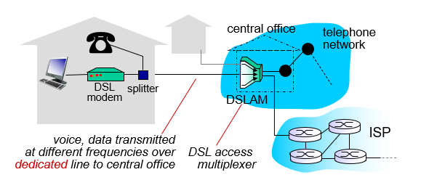

**Access network: cable network**

* HFC: hybrid fiber coaxial cables
  + *asymmetric* (like DSL)
  + up to 2 Mbps upstream transmission rate
  + up to 30 Mbps downstream transmission rate
  + *frequency division multiplexing:* different channels transmitted in different frequency bands
* network of cable, fiber attaches homes to ISP router
  + homes *share* access network to cable headend (unlike DSL, which has dedicated access to central office)

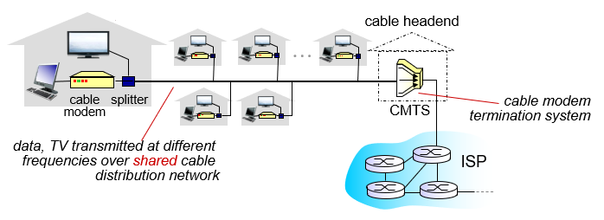

**Access network: home network**

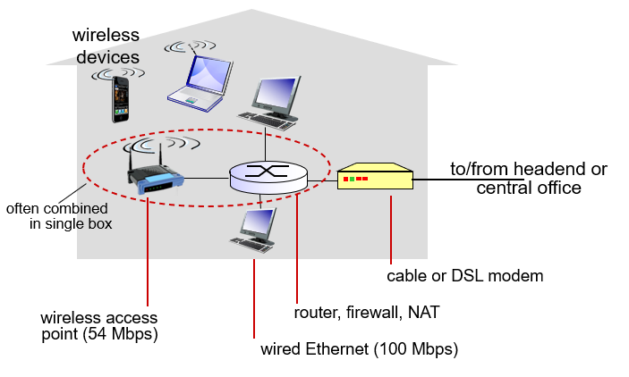

**Enterprise access networks (Ethernet)**

* typically used in universities, companies, etc.
* 10 Mbps, 100 Mbps, 1 Gbps, 10 Gbps transmission rates
* today, end systems typically connect into Ethernet switch (even home computers)

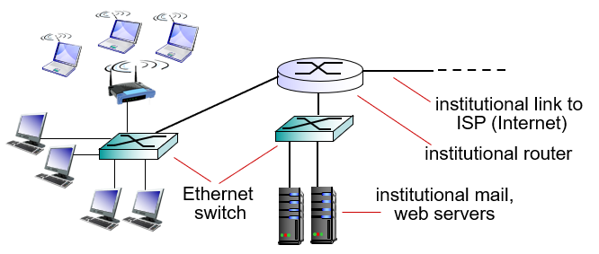

**Wireless access networks**

* the shared wireless access network connects end systems/hosts to router via base station (aka access point)
  + *wireless LANs:*
    - within building (100 ft)
    - 802.11 b/g/n/ac/ax (WiFi): 11, 54 Mbps transmission rate
  + *wide-area wireless cellular access*
    - provided by telco operators, 10’s of km
    - between 1 and 10 Mbps
    - 3G, 4G, 4G LTE

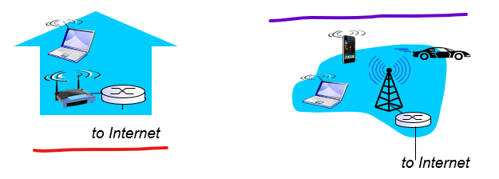

**Network core**

* mesh of interconnected routers
* packet-switching:
  + hosts break application-layer messages into *packets*/*datagrams*
  + forward packets from one router to the next, across links on path from source to destination
  + each packet transmitted at full link capacity

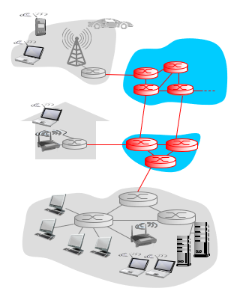

**Packet switching: queueing delay, loss**

* If arrival rate (in bits) to link exceeds transmission rate of link for a period of time:
  + Packets will queue, wait to be transmitted on link
  + Packets can be dropped (lost) if memory (buffer) fills up

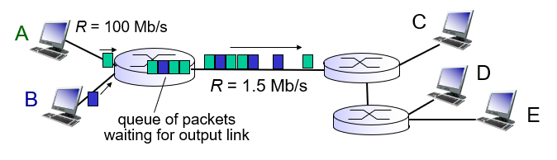

**Internet structure: network of networks**

* End systems connect to Internet via access ISPs (Internet Service Providers)
  + Residential, company, and university ISPs
* Access ISPs in turn must be interconnected so that any two hosts can send packets to each other
* Resulting network of networks is very complex
  + Evolution was driven by economics and national policies

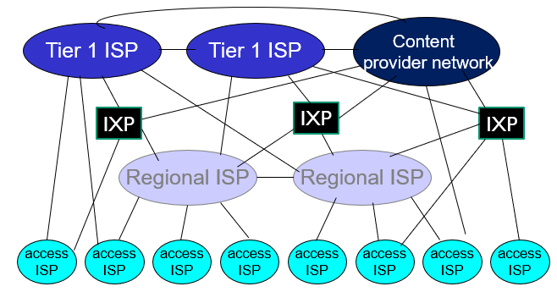

* At the center: small number of well-connected large networks
  + tier-1 commercial ISPs (e.g. Sprint, AT&T, NTT), national and international coverage
  + content provider network (e.g. Google, Microsoft); private network that connects its data centers to the Internet, often bypassing tier-1, regional ISPs
* At the edge of network core: regional networks connect access networks to ISPs

**Network models and layers**

* All networks provide the same basic functions to transfer a message from sender to receiver.
* However, each network is still very complex; there are many components involved and they can vary from network to network:
  + end-systems: clients, servers
  + networking: applications, links to various media, protocols
  + hardware and software
* All of these components have to work together to successfully transfer a message.
* One way to accomplish this is to use “layering”:
  + Break entire set of communications functions into a series of layers, each of which can be defined separately
  + Each layer implements a service via its own internal-layer actions, relying on services provided by layer below.
* There are many different models of network layering stacks…
  + OSI reference model
  + Internet model
* Why layering?
  + explicit structure allows identification, relationship of complex system’s pieces
  + possible to develop software + hardware to provide the functions of each layer separately
  + modularization eases maintenance, updating of system
    - change of implementation of layer’s service transparent to rest of system; e.g. change in gate procedure doesn’t affect rest of system

**Open Systems Interconnection (OSI) Reference Model**

* The “most talked about” and “most referred to” network model.
  + A framework of communication standards
  + Created in 1984 by the OSI subcommittee of the International Organization of Standardization (ISO)
* Comes up in network certification exams
* Not used anymore, except in some European networks (overtaken by the Internet model)
* Consists of 7 layers (compared to 5 with the Internet model):
  + **L1 – Physical**: transmitting data bits (0s and 1s) over a communication circuit; defines rules by which bits are transmitted (e.g. voltages, bitrate)
  + **L2 – Link**: data transfer between neighboring network elements; marks where a message starts and ends; performs error detection and correction
    - Ethernet, 802.11 (Wi-Fi), PPP
  + **L3 – Network**: routing of packets/datagrams from source to destination; determines best route through the network
    - internet protocols (IP), routing protocols
  + **L4 – Transport**: deals with end-to-end issues, e.g. procedures for entering and departing from the network; links the application layer software to network layer; establishes end-to-end connections for data transfer between sender and receiver; breaks up large transmissions into smaller packets and vice versa
    - TCP (reliable), UDP (unreliable)
  + **L5 – Session**: responsible for managing and structuring all sessions (syncing, checkpointing); must arrange for services on session initiation and provides for termination; recovery of data exchange (in case of session failure)
  + **L6 – Presentation**: formats data for presentation to user (e.g. editing user i/o, displaying, formatting); main job is to accommodate different interfaces on different computers
  + **L7 – Application**: end user’s access to network; provides a set of utilities for network applications; also does network monitoring and management.

**Internet model**

* The network model that currently dominates networks around the world
* Not developed by formal committees, never formally defined
* Developed from the work of thousands of individual network developers
* Main difference from OSI model is that it combines the top 3 OSI layers into 1 layer

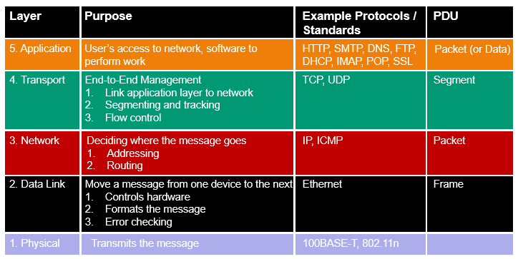

Groups of layers*

**Protocols and Encapsulation**

* **Protocol** defines the language of transmission and specifies the rules, functionality, and messages for network communication at every layer
* **Protocol Data Unit** (**PDU**) contains layer-specific information necessary for a message to be transmitted through a network
  + Each layers adds a PDU
  + PDUs act like nested envelopes
  + **Encapsulation** occurs when a higher level PDU is placed inside of a lower level PDU, for instance an HTTP request is put in a TCP segment, which is put inside an IP packet…

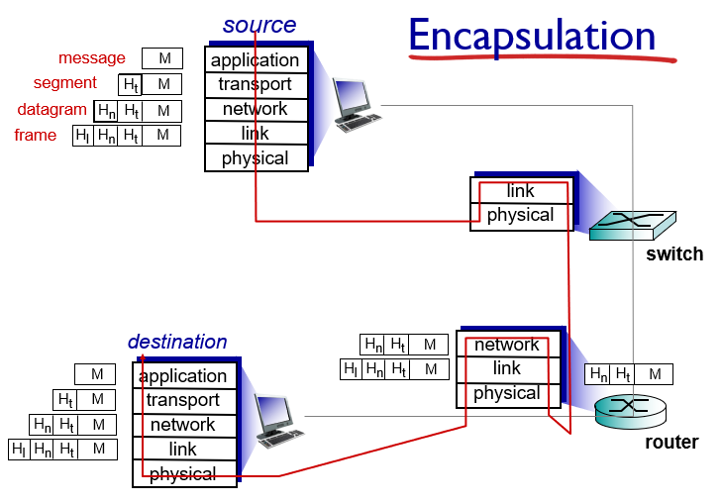

* M = message at application layer
* $H_{t}=$ segment at transport layer
* $H_{n}$ = datagram/packet at network layer
* $H_{l}$ = frame at link layer

**Message transmission using layers**

* Application layer:
  + User creates a message at the application layer using a web browser by clicking on a link
  + Web browser uses a specific protocol (HTTP – hypertext transfer protocol)
  + The browser application translates the user’s message into HTTP…
    - creates a specific PDU (an HTTP packet)
    - fills it in with the necessary information (e.g. return/receive address)
    - puts the user’s request inside the packet
    - passes the packet to the transport layer
* Transport layer:
  + Uses a protocol called TCP (transmission control protocol) with its own rules and PDUs.
  + TCP is responsible to breaking large files into smaller packets and for opening a connection to the server for transfer of a large set of packets.
  + The transport layer…
    - places the HTTP packet inside a TCP PDU (i.e. a TCP segment)
    - fills in the necessary information needed by the TCP segment
    - passes it to the network layer
* Network layer:
  + Uses a protocol called IP (internet protocol), which has its rules and PDUs.
  + The network layer’s tasks:
    - selects the next stop on the message’s route through the network
    - places the TCP segment inside an IP PDU, aka IP packet
    - passes the IP packet to the data link layer
* Data link layer:
  + If you are connecting to the internet, the data link layer may use a protocol called Ethernet.
  + Link layer’s tasks
    - formats the message with start/stop markers
    - adds error checking information
    - places the IP packet inside an Ethernet PDU (or Ethernet frame)
    - instructs the physical hardware to transmit the frame

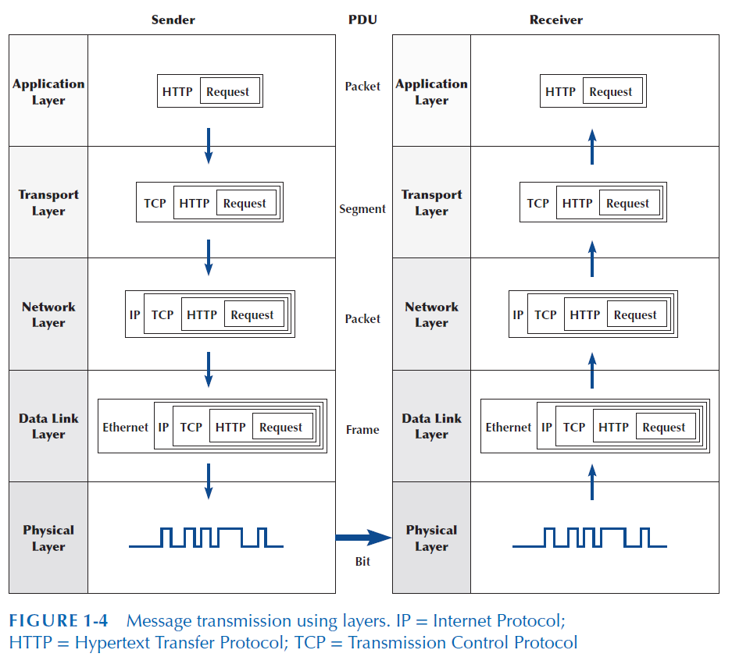  
HTTP = Hypertext Transfer Protocol; TCP = Transmission Control Protocol; IP = Internet Protocol